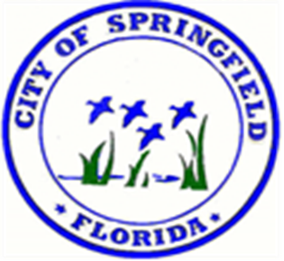
CITY OF SPRINGFIELD
Attn: Code Compliance
408 School Ave. Springfield, Fl.32401
Telephone (850) 872-7570 Fax: (850) 872-7663

REQUEST FOR LIEN SEARCH
Date: ___________________
Rush: ( ) $100.00 per Parcel ID Number in (3) business days
Regular: ( ) $50.00 per Parcel ID Number in (7) to (14) business days
Duplicate Request: ( ) $5.00 per Parcel ID Number

Company Name: ________________________________________________________________
Attention: _____________________________________________________________________
Address: ______________________________________________________________________
City: ____________________________ State: ________________ Zip Code: _______________
Phone: ( ) _____________________ Fax: (___) _____________________________________
Email Address: _________________________________________________________________

Owner(s) Name: ________________________________________________________________
Contact Information: ____________________________________________________________
Property Address: ______________________________________________________________
Parcel ID Number: ______________________________________________________________
Each lien search provides outstanding municipal debts assessed on a specific city property through a utility account, code enforcement or nuisance abatement case, special assessment, and/ or open building permit. Should there be an outstanding municipal debt, payments and release of liens are to be processed by the City Clerk’s office. *** Please note the processing begins upon the receipt and processing of payment. Payments received after 10:00 a.m. will not be processed until the following business date. ***

